**2025 Taiwan THz Summer Workshop Website Info**

Follow ACUPs Template (<https://www.acup2025.com/>)

**Home**

2025 Taiwan THz Summer Workshop | June 26th - June 28th, 2025, Hsinchu, Taiwan

(THz Workshop Intro) TBD

**Conference Chair:**

Shang-Hua Yang (National Tsing Hua University, Taiwan)

**Conference co-Chair:**

Chih-Wei Luo (National Yang Ming Chiao Tung University, Taiwan)

**Conference Secretary:**

Shelly Lee (THz Optics & Photonics Center, Taiwan)

**Organizing Committee:**

**Chair**

Rayko Ivanov Stantchev (National Sun Yat-sen University, Taiwan)

**Members**

Hsin-Yu Yao (National Chung Cheng University, Taiwan)

Chun-Hsing Li (National Taiwan University, Taiwan)

Chien-Nan Kuo (National Yang Ming Chiao Tung University, Taiwan)

Chien-Ming Tu (National Yang Ming Chiao Tung University, Taiwan)

**Organized by:**  
Department of Electrical Engineering, National Tsing Hua University

**Co-organized by:**  
Department of Electrophysics, National Yang Ming Chiao Tung University

THz Optics & Photonics Center, National Tsing Hua University

Intelligent Sensor Alliance

**Sponsored by:**

Physics Research Promotion Center, National Science and Technology Council

Terahertz Optics & Photonics Center, National Tsing Hua University

Intelligent Sensor Alliance

(LOGO)

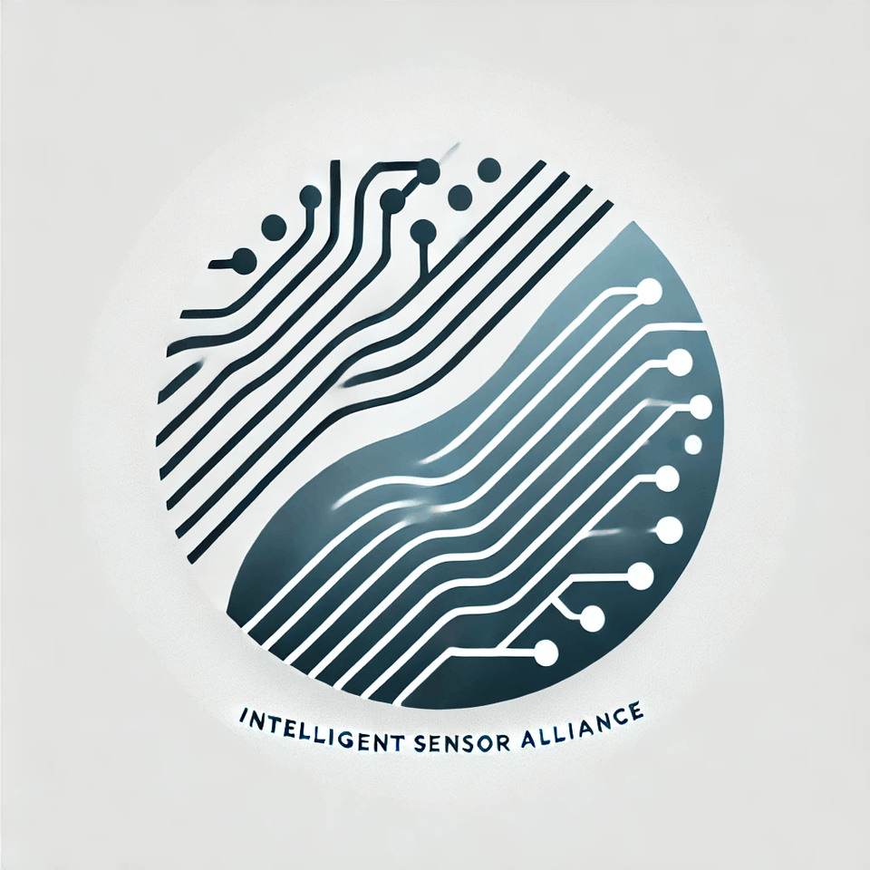

Speaker

Jong-Shinn Wu (Taiwan Space Agency, Taiwan)

Joo-Hiuk Son (University of Seoul, Korea)

Minah Seo (Korea Institute of Science and Technology, Korea)

Denis Bandurin (National University of Singapore, Singapore) - TBD

Shang-Hua Yang (National Tsing Hua University, Taiwan)

Chih-Wei Luo (National Yang Ming Chiao Tung University, Taiwan)

Hsin-Yu Yao (National Chung Cheng University, Taiwan)

Chun-Hsing Li (National Taiwan University, Taiwan)

Chien-Ming Tu (National Yang Ming Chiao Tung University, Taiwan)

Chia-Yi Huang (Tunghai University, Taiwan)

Chia-Yi Yeh (National Taiwan University, Taiwan)

Hai-Han Lu (National Taipei University of Technology, Taiwan)

Tsun-Hsu Chang (National Tsing Hua University, Taiwan)

**Venue**

**Venue**

SC001 (B1), NYCU Science Building III, No 1001, University Rd., Hsinchu 300, Taiwan

Google maps link: https://maps.app.goo.gl/bjYWRc1ZWxxqwe257

國立陽明交通大學 科學三館 (B1 次軒廳 )

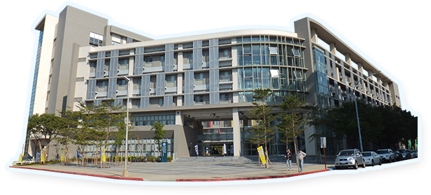

**Accommodation**

THE HO HOTEL (Hotel/HSR Free Shuttle Service)

THE HO HOTEL is the official accommodation for the 2025 Taiwan THz Summer Workshop, offering special reduced rates and essential assistance with your reservation. To book a room, please contact the conference secretary, Shelly Lee, at jh.lee@gapp.nthu.edu.tw, before May 30.

Address: No.16, Daxue Rd., East Dist., Hsinchu City 300, Taiwan

Tel: +886-3-571-5888 Email: fo@thehohotel.com.tw

Google map location: <https://maps.app.goo.gl/owuETkkwNpegJh458>

和選旅

地址300新竹市大學路16號

電話03-5715888 信箱fo@thehohotel.com.tw

**Transportation Guide**

Travel between the Hotel and Conference Venue (12 minutes walk)

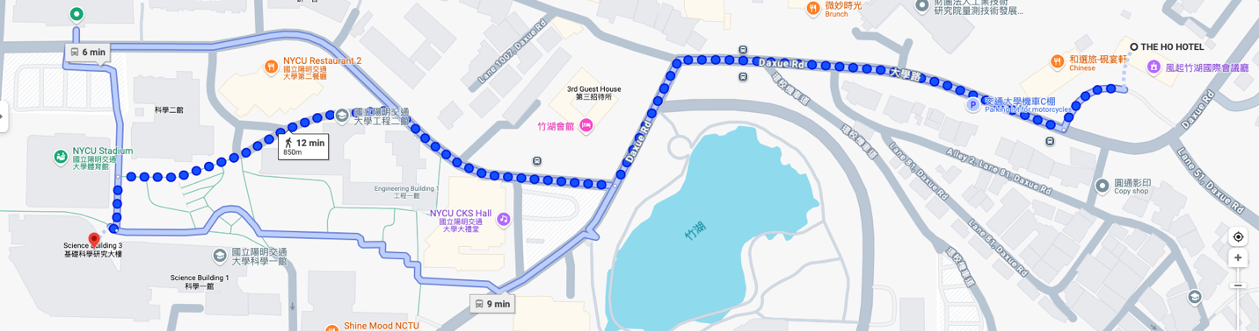

**From Taoyuan Airport to THE HO HOTEL**

**Method 1: Taxi (direct)**

to the THE HO HOTEL (和選旅)

Duration: 40–60 minutes (depending on traffic).

Cost: NT$1,200–1,500.

**Method 2: Bus + Walk (9 mins)**

1. Take the Bus (#1250, RI HAO BUS) from **the Taoyuan International Airport Terminal 1/Terminal 2 Stop** to **National Yang Ming Chiao Tung Stop**. Duration: 50 - 70 minutes. Cost: NT$200.

2. **National Yang Ming Chiao Tung Stop**, walk toward Daxue Rd for 3-4 mins and take the right turn. Walk for 4-6 mins to the THE HO HOTEL (和選旅).

Total Duration: 60 – 80 minites

Total Cost: NT$200.

**Method 3: Airport MRT + High-speed rail (HSR) + Free Shuttle**

1. Take the **Taoyuan Airport MRT** (Blue Line) from the airport to **Taoyuan HSR Station** (A18). Duration: 17-20 minutes. Cost: NT$25.

2. At Taoyuan HSR Station, take a high-speed rail (HSR) from **Taoyuan Station** to **Hsinchu Station**. Duration: 10 minutes. Cost: NT$130.

3. Take free shuttle* from Hsinchu HSR station directly to the THE HO HOTEL (和選旅). Duration: 10 minutes. *Reserve in advance.

Total Duration: 60 - 70 minites

Total Cost: NT$155.

**Agenda**

(TBD)

June 25 (Wed), 2025

16:00 – 17:00 Registration (Location: THE HO HOTEL)

June 26 (Thu), 2025

8:00 – 8:50 Registration (Location: SC001 (B1), NYCU Science Building III)

8:50 – 9:00 Opening Ceremony

9:00 – 9:45 Plenary Talk

9:45 – 12:30 Session A

12:30 – 13:30 Lunch

13:30 – 14:30 Poster Session

14:30 – 17:45 Session B

17:45 – 18:30 Transportation

18:30 – 20:30 Dinner

June 27 (Fri), 2025

8:00 – 9:00 Registration (Location: SC001 (B1), NYCU Science Building III)

9:00 – 9:45 Plenary Talk

9:45 – 12:00 Session C

12:00 – 12:30 Lunch

12:30 – 13:30 Poster Session

13:30 – 15:30 Session D

15:30 – 15:40 Closing Ceremony

15:40 – 21:00 Excursion

June 28 (Sat), 2025

8:00 – 17:00 Excursion

**Call for abstract**

(TBD)

**Excursion**

Date:

June 27 (Fri) & June 28 (Sat), 2025

Price:

200 USD (International) / 6000 NTD (Local). Accompanying person: 150 USD (International) / 4500 NTD (Local)

Excursion flyer:

Download

**Registration**

Registration is now open. Register before May 15th to receive a discount.

Click HERE to register.

Regular registration fees include lunch, refreshment and banquet. Student registration fees include lunch and refreshment.

**International Registration Fee**

Early-bird (by May 15, 2025):

Regular: 300 USD /Student: 100 USD

Late (from May 16, 2025) / Onsite:

Regular: 400 USD / Student: 150 USD

**Domestic Registration Fee**

Regular: 5000 NTD / Student: 1500 NTD

Additional banquet ticket for accompanying person: 40 USD (International) / 1200 NTD (Local)